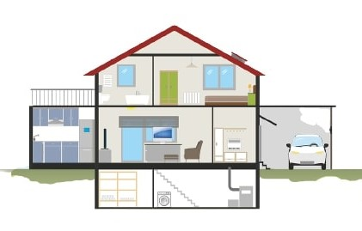

|  |
| --- |
| kitchen, car, solar panels, garage, living room, roof, bath, washing machine, bedroom, bathroom, steps, door, fridge, window, sofa (or chair). |